EUROPEAN ASSOCIATION OF MEDICAL HYPNOTHERAPY AND SUBCONSCIOUS THERAPY
Dr. ELENA GABOR, HYPNOSIS INSTRUCTOR

19
REGISTRATION FORM FOR HYPNOSIS/HYPNOTHERAPY, MEDICAL HYPNOTHERAPY, PAST LIFE REGRESSION THERAPY, LIFE BETWEEN LIVES REGRESSION AND GUIDED MEDITATION CERTIFICATION PROGRAM

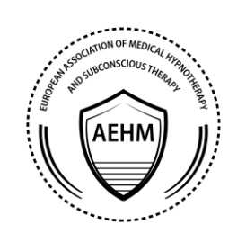

CERTIFICATION PROGRAM
IN HYPNOSIS / HIPNOTHERAPY
MEDICAL HIPNOTHERAPY
PAST LIFE REGRESSION THERAPY
LIFE BETWEEN LIVES REGRESSION
AND GUIDED MEDITATION
2018-2019

PERSONAL INFORMATION

Name:
Address:
City:
State:
Zip Code:
Phone Number:
Email:
Birth date:
Occupation/ Profession:
Education:
Other Hypnotism Training/ Memberships:
I have practice hypnosis since:
Have you ever been convicted of a felony?

CANCELATION RULES

If a student would like to withdraw from the certification training after receiving the access to the Online Module or after the training has started, the fee is nonrefundable.
*By registering to the certification program you agree with the terms and conditions.

After filling out this form please send it via email to drelenagabor@yahoo.com

THANK YOU! WE ARE LOOKING FORWARD TO HAVING YOU IN OUR CLASS!

For any questions please contact Dr. Elena Gabor at
drelenagabor@yahoo.com
001-310-614-9919

